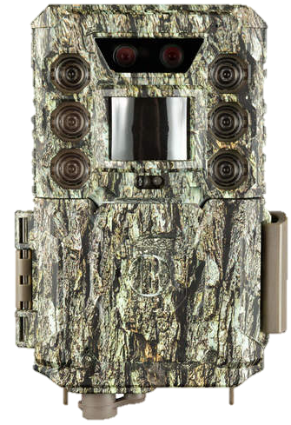
Core™ DS 4K Trail Camera
Most trail cameras use only one image sensor to capture images 24 hours a day. So you settle for daytime images that are less sharp and rich, and nighttime images that lack consistent illumination and range. CORE DS Dual Sensor Technology gives you two image sensors—one optimized for more sharp and rich images during the day and another optimized for images with consistent and further illumination at night. So you can plot their movements more reliably and plan your hunts more strategically.

- Pro Settings
  - Vivid Color Mode
  - Manual Exposure
White Balance
Transition Time Adjustment
- 150 feet night range
- 30 megapixels
- 0.2s trigger speed
- 3-Preset Menus + Advanced Mode
- In-Camera Color Review LCD (2 Models)
- 0.6s recovery rate
- 4K 30fps video w/audio
- 1-year battery life
- Removable Battery Tray
- Two-year limited warranty
SKU | DESCRIPTION | UPC | MSRP
119985C | 30MP Core DS Camo 4K Low Glow | 0-29757-00607-3 | $ 249.99

BUSHNELL.COM

